A crime has taken place and the detective needs your help. The detective gave you the crime scene report, but you somehow lost it. You vaguely remember that the crime was a **murder​** that occurred sometime on ​**Jan.15, 2018​** and that it took place in ​**SQL City​**. Start by retrieving the corresponding crime scene report from the police department’s database.

SELECT * FROM crime_scene_report WHERE type='murder' AND date='20180115' AND city=’SQL City’;

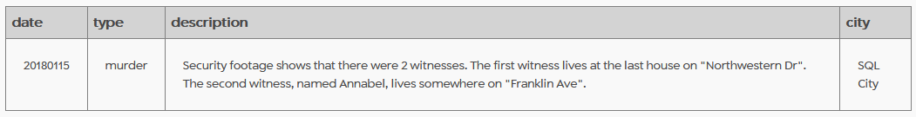

SELECT i.person_id,p.name,i.transcript, p.address_street_name   
FROM interview i  
INNER JOIN person p  
ON p.id=i.person_id  
WHERE address_street_name='Northwestern Dr'   
OR address_street_name='Franklin Ave'

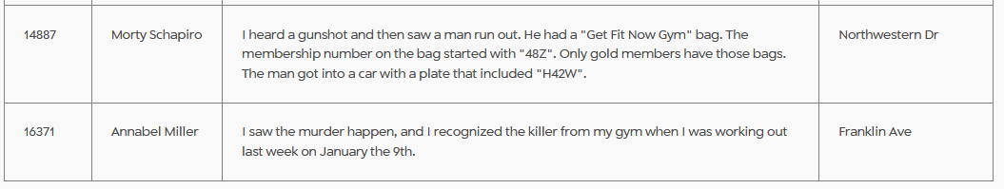

SELECT gfnm.id,gfnm.person_id,gfnm.name, gfnci.check_in_date  
FROM get_fit_now_member gfnm  
INNER JOIN get_fit_now_check_in gfnci  
ON gfnm.id=gfnci.membership_id  
WHERE gfnci.check_in_date='20180109' AND gfnm.id LIKE '48Z%';

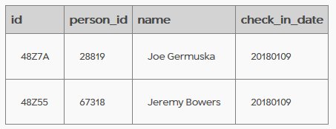

SELECT p.license_id, p.name, dl.plate_number  
FROM person p  
INNER JOIN drivers_license dl  
ON p.license_id=dl.id  
WHERE p.name='Joe Germuska'   
OR p.name='Jeremy Bowers';

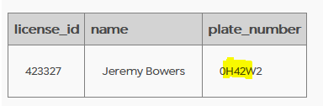

The culprit is Jeremy Bowers!